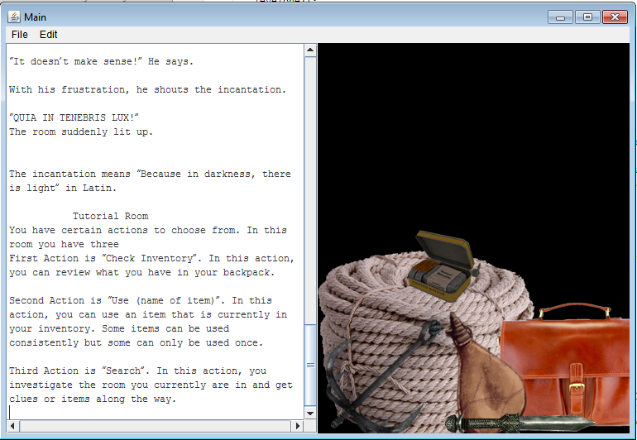

After the backstory have been displayed, the player will start the game, a set of instructions will be given for this tutorial level.

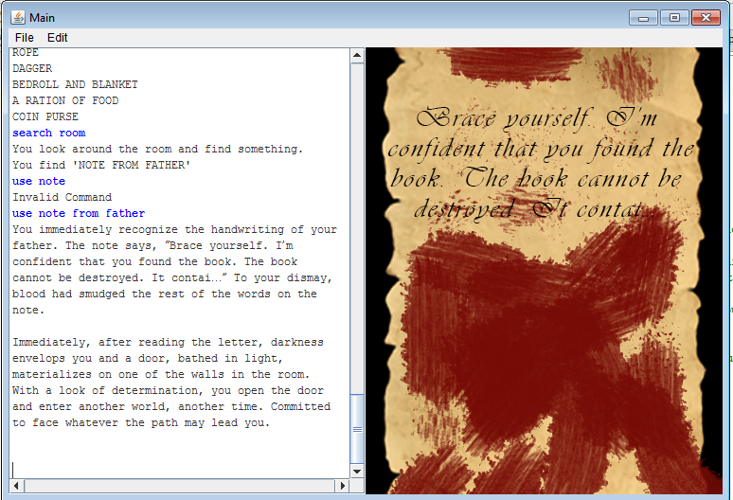

As shown above, the player should be able to type in the complete command in order the program to run correctly.  For example, if you type “Use note” it will display an invalid command.  Instead, type “Use note from father”.  This completes room one.

ROOM 2

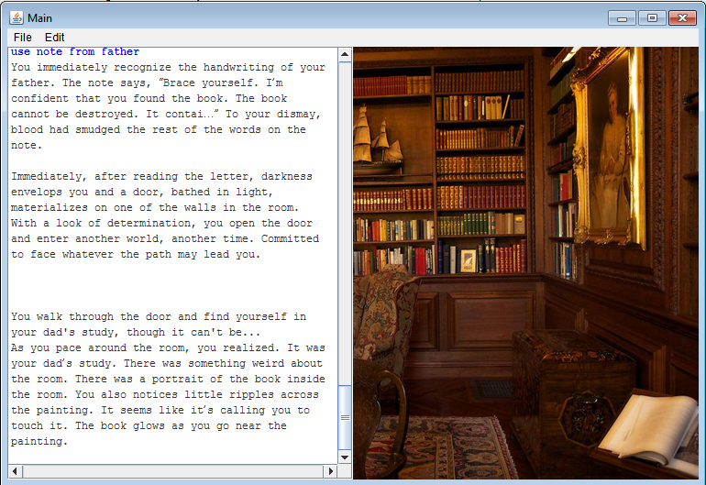

After the player completes room one, he will automatically go to the next level (room 2) a new story line and picture will be flashed.  These pictures help players to easily visualize the scene.

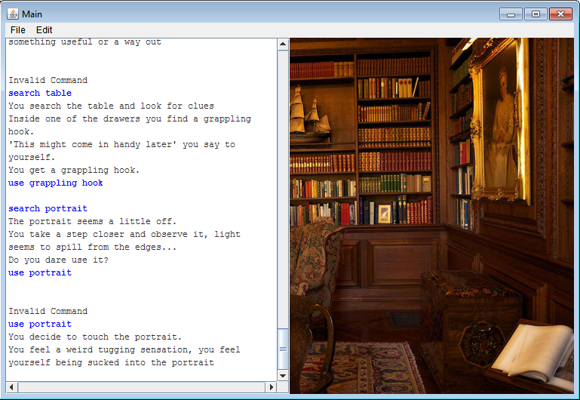

Players should use their logical thinking skills, in order to use items correctly.  Else, he might be stuck in the game.

FOR THE NEXT eight levels, screenshots would not be shown, to discover the fable of the lost is for you to find out, so play this game!

CONCLUSION:

Fable of the Lost is a text-based game that implements data structures, ACM Graphics package, and OpenCV. The game is made through the use of two data structures, namely, a list and a binary search tree. The game also uses OpenCV and ACM graphics for the design of the images and the cut scenes. The game focuses on the enjoyment of the people who use it and the logic building concept. This project is done through the use of IntelliJ IDEA 2016 software, Adobe Photoshop, and Open Broadcaster Software.

ACKNOWLEDGEMENT

We would like to thank our professor, Engr. Melvin Cabatuan who gave us the opportunity to do this wonderful and challenging project by applying data structures learned in class, in which it also helped us improve our programming skills and creative thinking.

**REFERENCES**

1. AtrusHB, "Riven: The sequel to Myst - Moiety cave puzzle solved Cutscene," in YouTube, YouTube, 2011. [Online]. Available: https://www.youtube.com/watch?v=umcWiYhro-w. Accessed: Aug. 24, 2016.
2. De Peza, "Exploring Averye’s dark cave: UNCHARTED 4 A thief end episode 10," in YouTube, YouTube, 2016. [Online]. Available:https://www.youtube.com/watch?v=APAIguOy9Ww. Accessed: Aug. 28, 2016.
3. Fungo, "Youtube," in www.youtube.com, 2010. [Online]. Available:https://docs.google.com/a/dlsu.edu.ph/document/d/1XXRa8R_g4qZD83R0O5LK05CrT1Amk5Yyjj_M-gHTOEs/edit?usp=sharing. Accessed: Aug. 25, 2016.
4. NoMaD, "FPS creator x9 subway cutscene," in YouTube, YouTube,2015.[Online].Available:https://www.youtube.com/watch?v=J9NY4yNPuEk. Accessed: Aug. 27, 2016.
5. Eyjold, "Graph and its representations," in Graph, GeeksforGeeks,2012.[Online].Available:http://www.geeksforgeeks.org/graph-and-its-representations/. Accessed: Aug. 04, 2016.
6. S. Claridge, "Implementing a binary search tree (BST) in java," in Java, More Of Less, 2014. [Online]. Available: http://www.moreofless.co.uk/binary-search-tree-bst-java/. Accessed: Aug. 04, 2016.
7. SJ, "Binary search tree complete implementation in JAVA," in Algorithms, Algorithms, 2014. [Online]. Available: http://algorithms.tutorialhorizon.com/binary-search-tree-complete-implementation/. Accessed: Aug. 04, 2016.